**LANDIS-II-Site-Browse-Tool**

The L2-Site-Browse tool is a variant of the standard L2-Site tool (v2.4) with features added to demonstrate the functionality of the Browse Disturbance Extension. Use the L2-Site Users Guide to become familiar with the tool and how it operates in general. Parameters added specific to the Browse extension are located in the far right column of the interface, and in a section below the other species parameters.

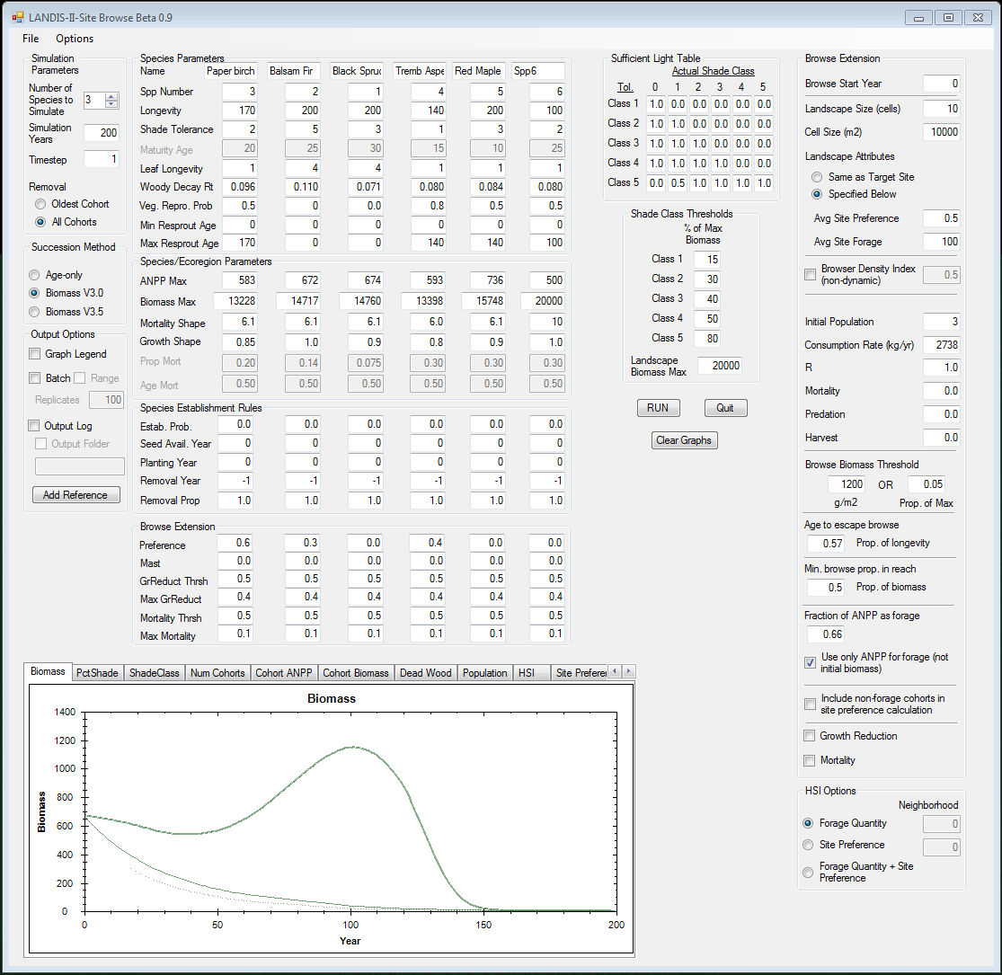

The Browse Disturbance Extension Users Guide provides information about the parameters and calculations used in the tool. Additional output graphs are provided for the Browse tool, including: Browser **Population**, Habitat Suitability Index (**HSI**), **Site Preference**, **Forage** Quantity, Quantity of **Forage in Reach**, and **Browsed** Forage.

Several check boxes turn on and off certain components of the Browse Extension. For example, checking the box labeled ‘Browser Density Index (non-dynamic)’ makes the browser population not responsive to forage conditions.

All inputs are directly related to input parameters for the extension, with the exception of the landscape parameters (i.e., Landscape Size, Cell Size, Landscape Attributes). These parameters determine how the remainder of the landscape (outside the cell being simulated) is treated. Because the browser population is modeled at the landscape/zone-level in the extension and the model tracks real numbers of browsers, the status of the rest of the landscape is relevant for population calculations (when modeling a dynamic population). The Initial Population parameter should be scaled to match the landscape size being simulated with the tool. The Landscape Attributes option of ‘Same as Target Site’ will use the calculated site preference and site forage values for the simulated site to apply to all other landscape sites when calculating the population. The option of ‘Specified Below’ will use the entered values for site preference and forage for all other landscape site.

**Release Notes:**

Version Beta 0.11: Fixed bug related to biomass removed by browse. Previous version allowed calculation of negative biomass removed, which resulted in positive biomass change due to browse in some circumstances.

Version Beta 0.10: Fixed discrepancy between site tool and biomass succession regarding cohort competition and growth mortality. Growth mortality was previously being overestimated as cohort competition increased.